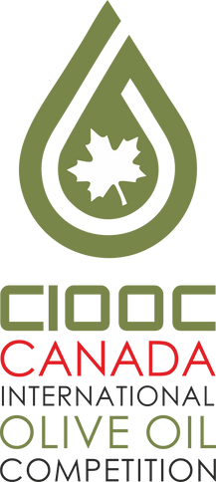PACKAGING Olive oil Competition 2022
CANADA IOOC 2022
Canada International Olive oil Competition
Official Participation Form

I, the undersigned, hereby grant the organizers the right to use my details for the competition reason

Company name : _______________________________________________________________________________

Address: ______________________________________________________Post Code:_______________________

City: __________________________________________Country: ________________________________________

Mobile phone: ______________________________________Email: _____________________________________

____________________________________________ Web site: _________________________________________

Person in charge: _______________________________________________________________________________

Name of designer Company name of

designer: ___________________________________________________________ Retail price €

I agree and I submit my brand(s) under the product name(s):

1st product name ______________________________________________________________________________

2nd product name______________________________________________________________________________

3rd product name: _____________________________________________________________________________

4th product name: _____________________________________________________________________________

IN THE SAME BOX include: a) The participation form AND b) three (3) samples. If you have finished and packed the box, call your courier company to transport this box to Canada.

___________________________________________

Date Signed
___________________________________________

Entrant's Signature

W W W . C A N A D A I O O C . C O M

